Software Development 3

Lab 7

Consider the following class hierarchy:

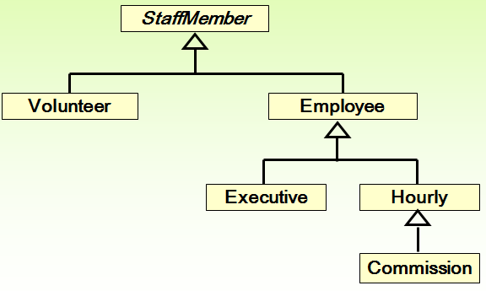

StaffMember Class

- Create an abstract class called StaffMember, with member variables name, address and phone number.
- The constructor should require values for all variables.
- Create a toString() method that displays the details of the member variables.
- Create an abstract pay() method that returns a value of type double (with no implementation).

Volunteer Class
- Create a class called Volunteer with no new member variables.
- Create a suitable constructor.
- Create a pay() method that returns 0 pay for a volunteer.

Employee Class
- Create a class called Employee with 2 additional member variables rsiNumber and rate of pay (salary).
- Create a suitable constructor.
- Create a toString() method that displays appropriate data for this class – no need to include the pay here.
- Create a pay() method that returns the pay rate (salary).

Hourly Class
- Create a class called Hourly with 1 additional member variable for hours worked.
- Create a suitable constructor that initialises appropriate variables and sets the hours worked to 0.
- Create an addHours() method which takes 1 parameter representing the number of hours worked and uses this to update the hours worked.
- Create a pay() method that returns the payment due (payRate * hoursworked).
- Create a toString() method that displays appropriate data for this class – no need to include the pay here.

Executive Class
- Create a class called Executive with 1 additional member variable to represent a bonus.
- Create a suitable constructor that initialises appropriate variables and sets the bonus to 0.
- Create an awardBonus() method which takes 1 parameter representing the amount of the bonus and uses this to update the bonus.
- Create a pay() method that returns the payment due. This amount should also include the bonus.

Commission Class
- Create a class called Commission with 2 additional member variables total sales and commission rate.
- Create a suitable constructor that initialises all appropriate variables (total sales can be assigned to 0).
- Create an addSales() method which takes 1 parameter representing the amount of sales achieved and uses this to update the sales.
- Create a pay() method that returns the payment due. This amount should also include the commission.
- Create a toString() method that displays appropriate data for this class – no need to include the pay here.

Staff Class
- Create a class called Staff with 1 member variable that represents 8 different staff members.
- Create a constructor which takes no parameters and creates 8 staff member objects and initialises them with the following data:

Type of Staff member | Name | Address | Phone Number | RSI Number | Rate of Pay | Comm Rate
Executive | John | 1 This St | 0874323476 | R6574635 | 2423.07
Employee | Paul | 2 That St | 0854345222 | P8884635 | 1246.15
Employee | Dave | 3 Other St | 0864343566 | S9876635 | 1169.23
Hourly | Joanne | 4 Long Ave. | 0836789676 | T0987635 | 10.55
Volunteer | Norma | 5 Short Ave. | 0864323456
Volunteer | Kate | 6 Pecks Lane | 0854676767
Commission | Molly | 7 Nowhere Rd. | 0864326789 | L6599635 | 6.25 | .2
Commission | Joe | 8 My Place | 0864344545 | G8888635 | 9.75 | .15

- Create a processStaff() method that calls the methods awardBonus(), addHours(), addSales() to perform the following operations:

    - Award a bonus of €500 to John
    - Joanne works 40 hours
    - Molly works 35 hours and she has sales of €400
    - Joe works 40 hours and he has sales of €950

- Create a payday() method that displays the appropriate amount of pay for each staff member

TestCompany Class
Create a test class which should create a Staff object and call the processStaff() and payday() methods.

Test Data
Name: John
Address: 1 This St
Phone: 0874323476
RSI Number: R6574635
Paid: 2923.07
-----------------------------------
Name: Paul
Address: 2 That St
Phone: 0854345222
RSI Number: P8884635
Paid: 1246.15
-----------------------------------
Name: Dave
Address: 3 Other St
Phone: 0864343566
RSI Number: S9876635
Paid: 1169.23
-----------------------------------
Name: Joanne
Address: 4 Long Ave.
Phone: 0836789676
RSI Number: T0987635
Current hours: 40
Paid: 422.0
-----------------------------------
Name: Norma
Address: 5 Short Ave.
Phone: 0864323456
Thanks!
-----------------------------------
Name: kate
Address: 6 Pecks Lane
Phone: 0854676767
Thanks!
-----------------------------------
Name: Molly
Address: 7 Nowhere Rd.
Phone: 0864326789
RSI Number: L6599635
Current hours: 35
Total sales: 400.0
Paid: 298.75
-----------------------------------
Name: Joe
Address: 8 My Place
Phone: 08643445454
RSI Number: G8888635
Current hours: 40
Total sales: 950.0
Paid: 532.5
-----------------------------------

